**ASSIGNMENT 4 : STORAGE APP**

**Submitted by :** Aishwarya Lodhi

**Objective:** Learning Objective: use android file and SQLite storage features to complete the assignment.

**Steps:**

1. **On Application build**

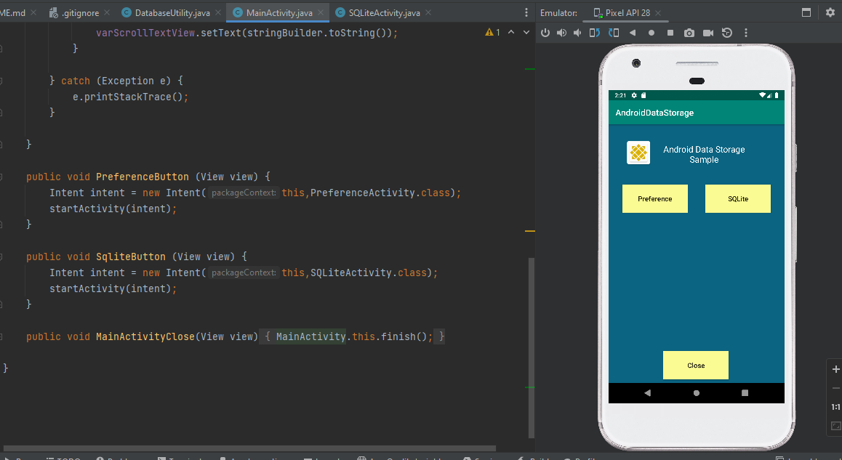

**2.On Preference we can provide review of book and it is stored as text file.**

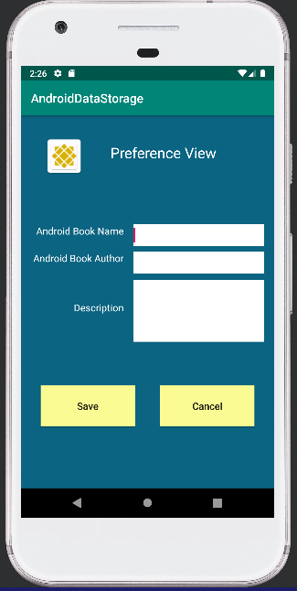**.**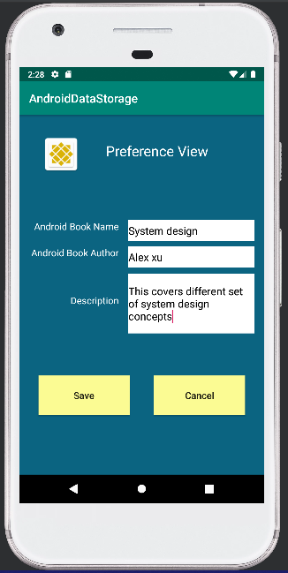

**3 on saving data , filename with file is displayed on screen**

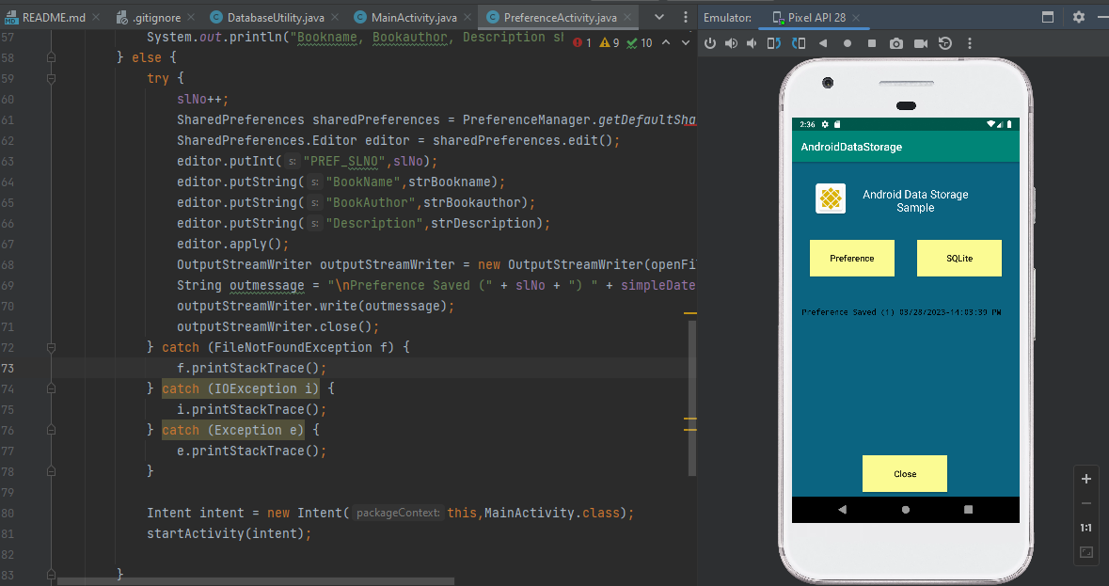

**File is stored in storage.**

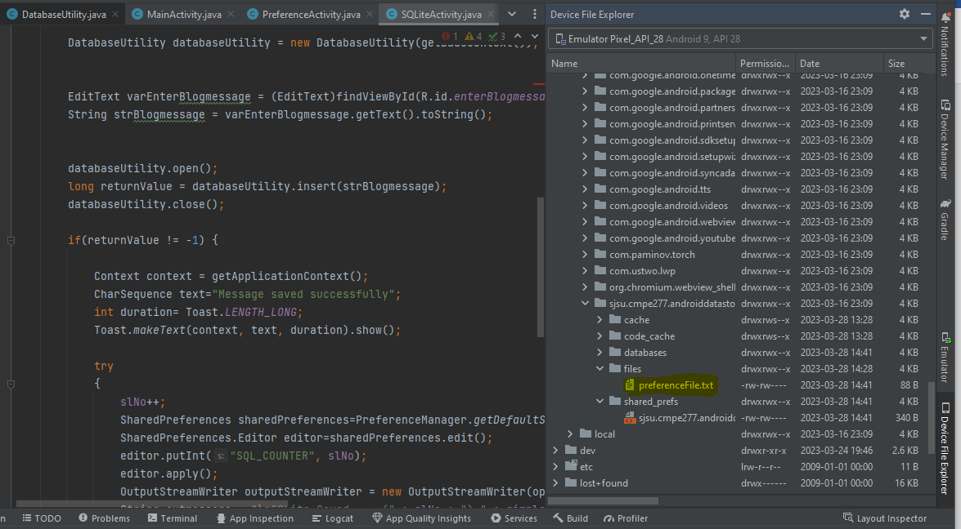

**For Database connectivity:**

**Creating Database utility class**

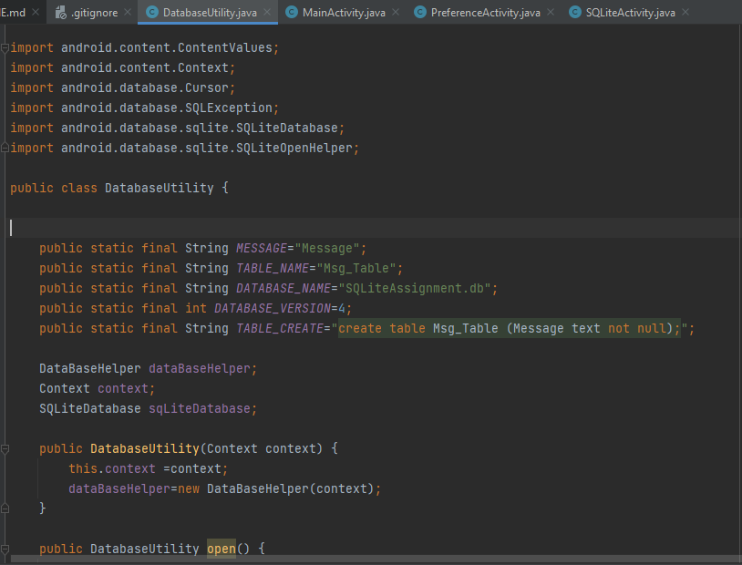

**On Sqlite option posting blog to store in DB.**

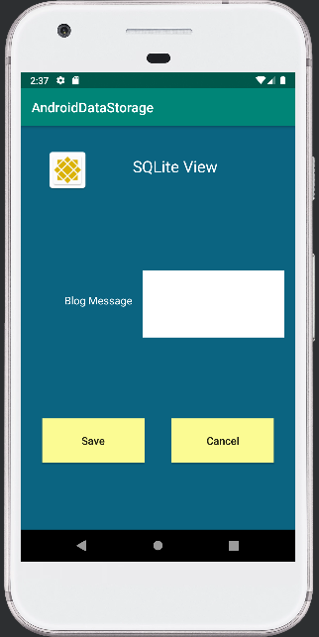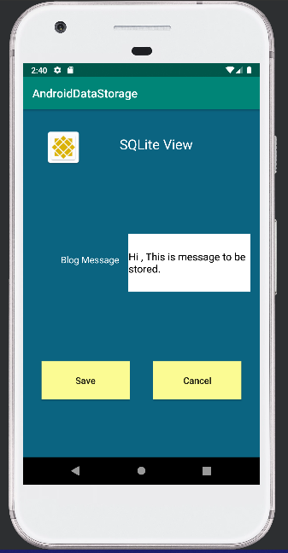

**On saving data is stored in Database.**

